Title: Airline Passenger Communication — Prompting Strategy Lab
Student name: Ansh
Roll number: 2620996504
Programme / Section: BBA AVIATION MANAGEMENT
Date:8-10-2026
Round 1 — Zero-Shot Prompting
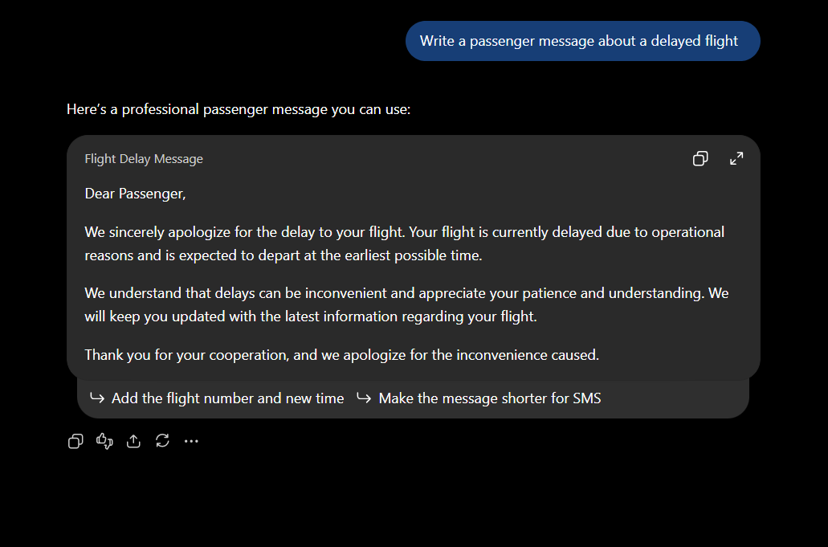
Observation:
The initial response was general. It still needed more details like flight detail and delay details before it could be used.

Round 2 — Context and Constraints
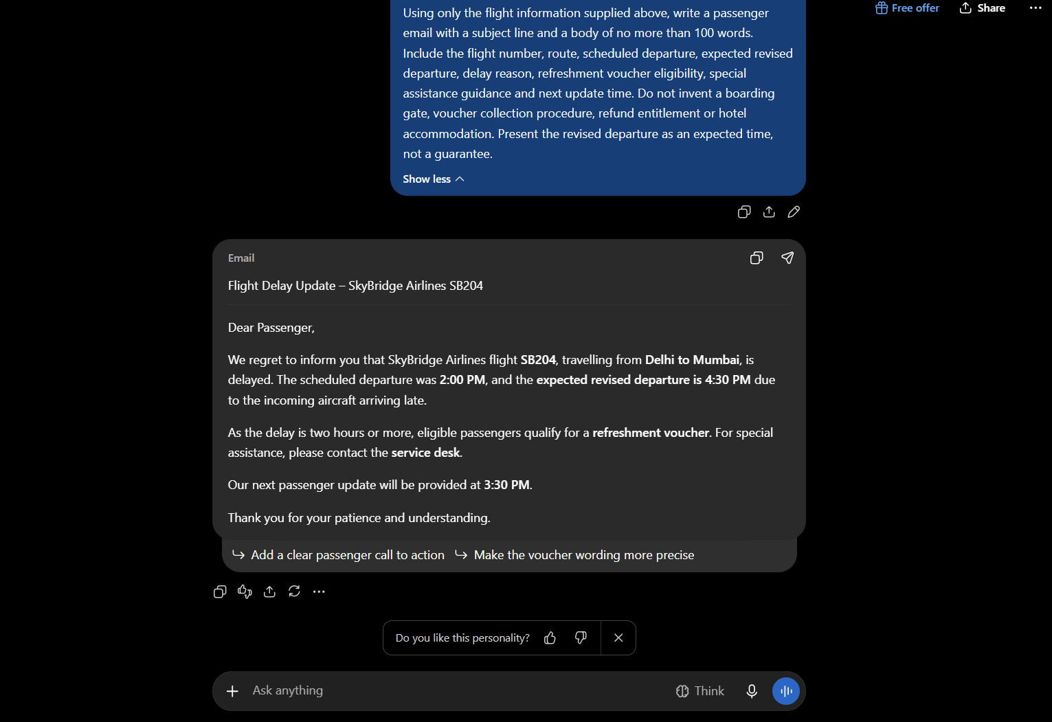
Observation:
Now in response it mentioned the all-flight details and didn’t mention about the hotel accommodation.

Round 3 — Role Prompting
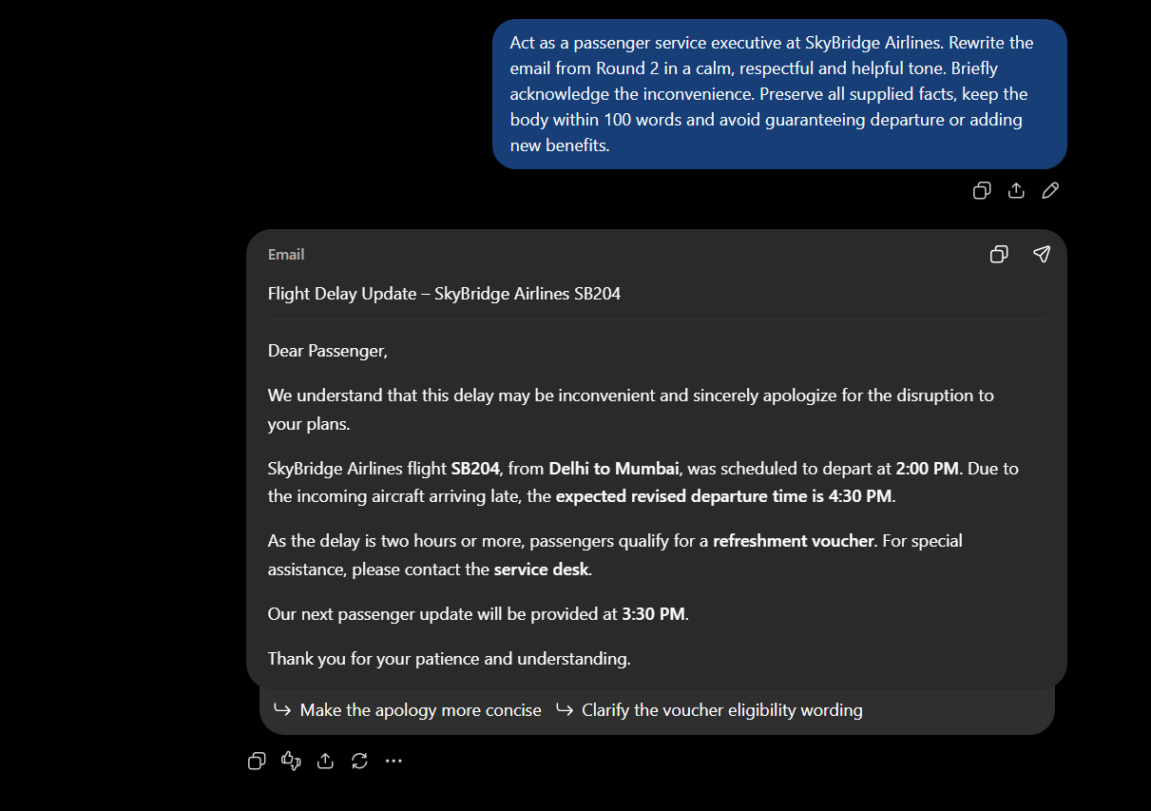

Observation:
Yes, it acknowledged the inconvenience and the wording is also Professional. Also didn’t change any fact.
Round 4 — Few-Shot Prompting

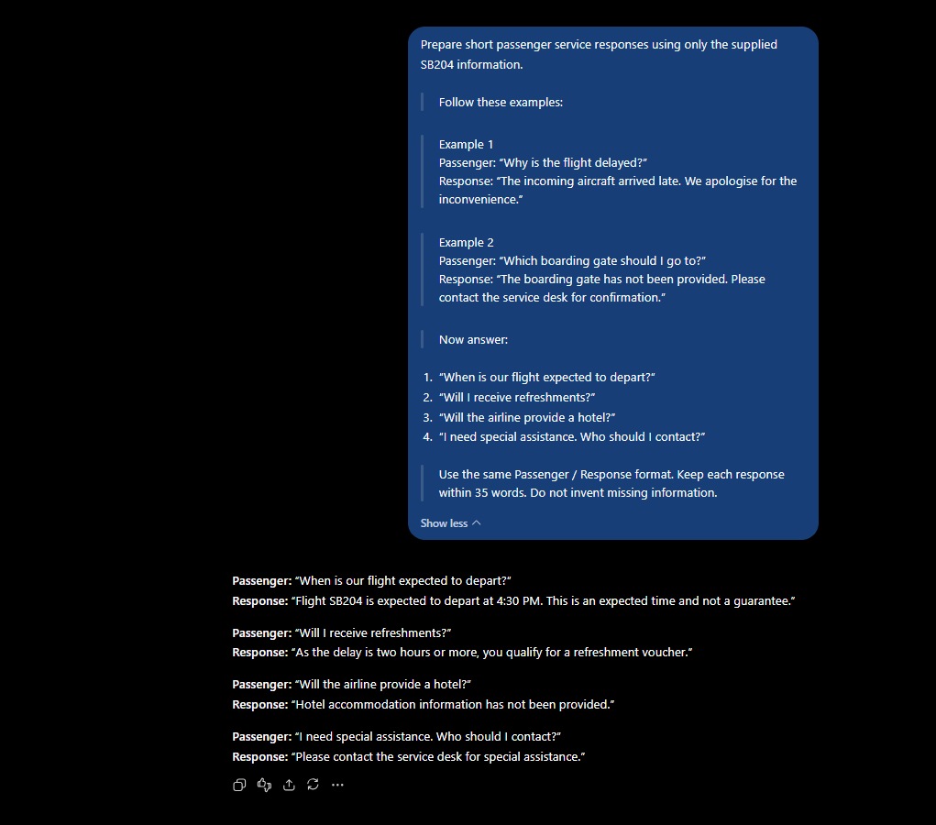

Observation:
Yes, the expected time is correct and Follows the Refreshment eligibility.

Round 5 — Structured-Output Prompting
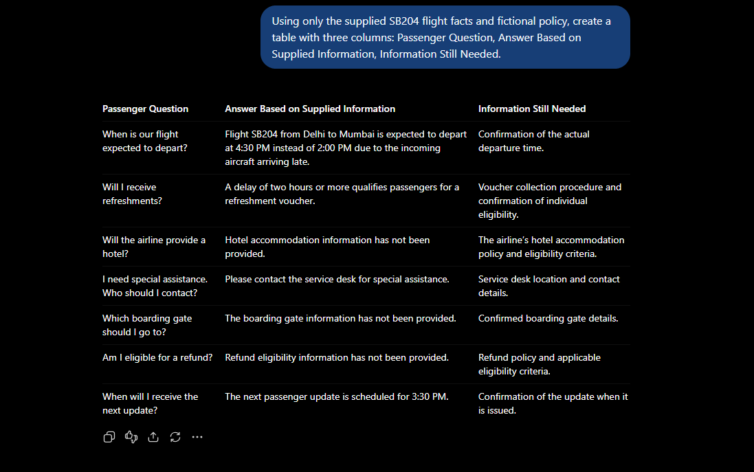
Observation:
The flight is expected to depart at 4:30 PM. The flight is delayed due to the incoming aircraft arriving late. A delay of two hours or more qualified passenger for a refreshment voucher. The boarding gate information has not been Provided. The refund eligibility information has not been provided.
Round 6 — Audience-Based Prompting
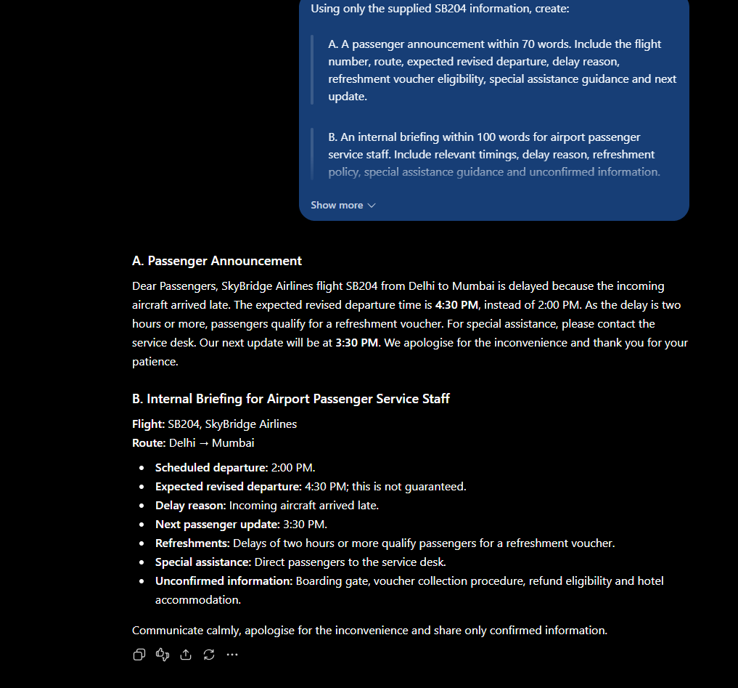
Observation:
Comparison point | Passenger announcement | Staff briefing
Intended reader | Passengers travelling on flight SB204 | Airport passenger service staff
Tone | Calm, respectful, simple and reassuring | Professional, clear and operational
Level of detail | Brief, focusing on delay, expected departure, refreshments, assistance and next update | More detailed, including timings, delay reason, policy and unconfirmed information
Comparison and Reflection
Round | Strategy | Main change observed | Detail checked or corrected
1 | Zero-shot | Generated a basic flight delay message. | Checked the flight details and departure time.
2 | Context and constraints | Included specific flight facts and clear restrictions. | Verified the expected departure time, delay reason and refreshment policy.
3 | Role prompting | Made the email more calm, respectful and helpful. | Ensured the revised departure was presented as an expected time, not a guarantee.
4 | Few-shot | Produced consistent passenger responses following examples. | Checked that missing information, such as hotel accommodation, was not invented.
5 | Structured output | Organised information into a clear comparison table. | Checked the distinction between supplied facts and information still needed.
6 | Audience-based | Adapted the language and detail for passengers and airport staff. | Ensured passengers received simple reassurance and staff received operational details.

